Yard Duty and Supervision Policy

Purpose
The purpose of this policy is to explain to staff of visiting schools and Somers School Camp the procedures and expectations for the appropriate supervision of primary students whilst at Woorabinda.
Appropriate supervision is an important strategy to monitor student behaviour and enables staff to identify and respond to possible risks at school as they arise. It also plays a vital role in helping schools to discharge their duty of care to students.
Considering the unique environment of the school activities undertaken, Woorabinda regularly reviews this policy and associated procedures.
This Policy takes into consideration the following environments:
- On campus supervision
  - Group Activities
  - Free time, Yard Duty and Site Boundaries
  - Meals Duty
  - Overnight Duty
- Excursions off-site activities supervision
Objective
To ensure that Woorabinda staff and visiting school staff understand their supervision and yard duty responsibilities.
Scope
The Woorabinda Campus Principal is responsible for ensuring that there is a well organised and responsive system of supervision and yard duty in place 24 hours a day during the 3-5-day program. This policy applies to all teaching and non-teaching staff at Woorabinda, including education support staff, and casual relief teachers.
This policy applies to all visiting school staff and non-teaching staff, including education support staff and volunteers.
Woorabinda and visiting school staff are responsible for following reasonable and lawful instructions from the Woorabinda Campus Principal, including instructions to provide supervision to students at specific dates, time, and places.
Policy
As the school operates 24 hours per day for up to 3-5 days, Woorabinda requires a comprehensive yard duty and supervision policy.
Woorabinda will have a staff to student ratio of 1 staff per 10 students.
Woorabinda will follow the Department of Education and Training required staff to student ratios at all time for outdoor or adventure activities. See Policy Advisory Library Link https://www2.education.vic.gov.au/pal/excursions/guidance/supervision

On Site Supervision

Group Activities
To manage the supervision of students while at Woorabinda, all students are allocated a group prior to attending, these groups are allocated a corresponding visiting school staff member.
In the pre-planning, groups of 18 students are allocated to a colour group: blue, green, yellow, orange and red. The students stay with these groups for the duration of the program. The students are given a coloured beanie in winter (Term 2 and 3) or a bucket hat in summer (Term 1 and 4) so that the students are always easily identifiable.
Our activity program starts at Assembly at 8:45am with all visiting teachers and rostered Woorabinda teachers in attendance.
The visiting school staff member will remain with the group through all rotational group activities (including on-site and excursion off-site activities) and duty group responsibilities (i.e., meal preparation and clean up).
The Woorabinda group teacher is responsible for the supervision of all students in their care during group activities (morning or afternoon session). If a teacher needs to leave the session unattended at any time during a lesson, he or she should first contact the visiting teacher for assistance. The Woorabinda group teacher should then wait until a replacement staff member has arrived before leaving where practicable. Woorabinda staff will manage all group activities and provided supplementary staff to support supervision.

Free Time Supervision
Woorabinda staff are on duty as follows:
- Dining Room from 7:00am – 9:15am (breakfast)
- Outdoor Eating area from 12:30pm – 1:00pm (lunch)
- Dining Room from 4:45pm – 6:30pm (dinner starts at 5.30)
Visiting teachers are on duty as follows:
- In the Dormitories from 8:30pm - 8:00am the following morning
- In the Dormitories from 8:00am – 8:45 am to brush teeth after breakfast
- On the Smoval and the asphalt area around the dormitories from 1:00pm – 1:15pm
- In the Dormitories from 4:30pm to 5:30 pm for showers
- Sedentary time in the Library, Dormitories, or Green Corner prior to dinner from 4:30 to 5:30pm
Dormitories are not accessible to the students during the day except the times outlined in the list above. Students can access the toilets in the dormitories as required during free-time and there are visiting school staff monitoring students use of the toilets.
All children arriving or leaving Woorabinda independently of the visiting school will be supervised at the administration building until they are signed in or out by a parent or carer or until they are handed over to the group teacher.
At all times visiting school staff and Woorabinda staff on duty are responsible for supervising students and must:
- be visible and out with students
- methodically move around the designated zones 1 and 2, and inside the building actively supervising students during the times allocated in the list above
- be alert and vigilant
- recognise and acknowledge positive behaviour
- intervene immediately if potentially dangerous or inappropriate behaviour is observed
- enforce behavioural standards and implement appropriate consequences for breaches of safety rules, in accordance with any relevant disciplinary measures set out in the Woorabinda’s Student Health and Wellbeing policy
- ensure that students who require first aid assistance receive it as soon as practicable
- log any incidents or near misses on be recorded on the day sheet.
- Any reportable incidents to the Department are reported through the School Incident Management System by both Woorabinda and the visiting school.
Staff on duty during meals are responsible for supervising student duty groups to:
- set-up the dining area.
- wash all dishes
- assist with cleaning the kitchen
- wipe down of tables and chairs in the common area.
Visiting staff on duty overnight will sleep in the appropriate gender wing, and are responsible for:
- ensuring students are in their own dorms/bunkbeds
- being available on call for student needs during the night
- ensuring the general security of the building
- student supervision in the morning
The Woorabinda Campus Principal, Leading Teacher and First Aid/Wellbeing Coordinator are on 24 Hour call to support and assist visiting teachers when required.

Supervision Zones
All visiting school staff at Woorabinda are expected to assist with yard duty supervision and will be included on the lunch duty roster.
The Woorabinda Leading Teacher is responsible for preparing and communicating the yard duty roster to visiting school staff via a duty roster in the visiting teachers’ lounge.
Zone | Area
Zone 1 | Smoval
Zone 2 | Asphalt, Dorms

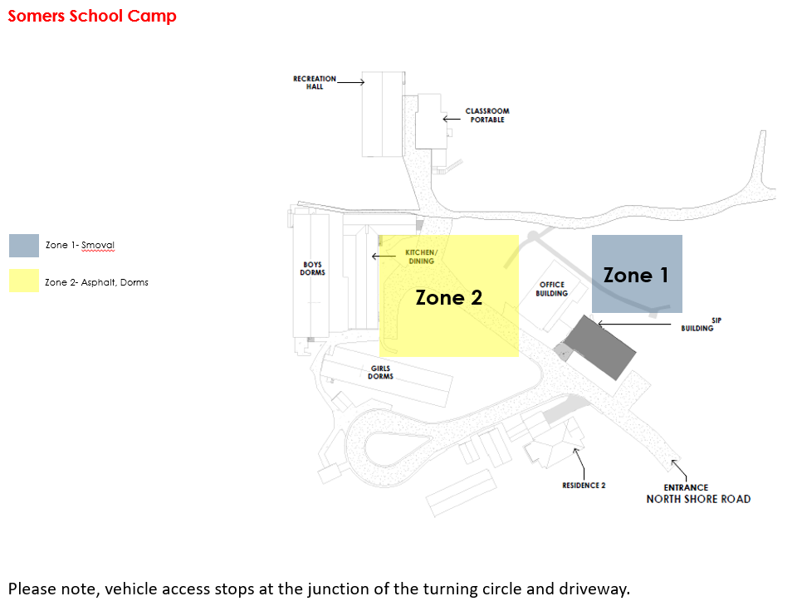

Staff rotation
Visiting school staff who are on duty must remain with the students where practicable until they are replaced by a relieving teacher. Visiting teachers are responsible for supervision of students, Woorabinda staff are available across the supervision zones along with first aid kits and will support when/if required.
If being relieved of their duty by another staff, the staff member must ensure that a brief, but adequate verbal ‘handover’ is given to the relieving staff member in relation to any issues which may have arisen during their shift, these issues should also be recorded in the day sheet.
If the supervising teacher is unable to supervise at the designated time, they should contact the Woorabinda Campus Principal with as much notice as possible prior to the relevant shift to ensure that alternative arrangements are made.
If the identified supervising teacher needs to leave, they must ensure another staff member supervises until the relieving teacher has arrived in the designated area.
School activities, camps and excursions
The principal and leadership team from the visiting school are responsible for ensuring that students are appropriately supervised during all school activities, camps and excursions, including when external providers are engaged to conduct part or all of the activity. Appropriate supervision will be planned for school activities, camps and excursions on an individual basis, depending on the activities to be undertaken and the level of potential risk involved.
The visiting schools are on camp from their school whilst attending Woorabinda and are responsible for all aspects of camp preparation (as per Department Camps and Excursion Policy).
There are no excursions that occur by the visiting school from Woorabinda as part of the program.
Supervision of students using digital devices
Students do not have access to digital devices while at Woorabinda.
Students requiring additional supervision support
Sometimes, students will require additional supervision, over and above the ratios provided in Department policy. In these cases, the Woorabinda campus principal or delegate will ensure arrangements are made, in consultation with the visiting school, to roster additional staff as required. This may include outside of hours, in the classroom or during school activities.
Communication
This policy will be communicated to our school community in the following ways.
- Included in Woorabinda staff and visiting school staff induction processes.
- Discussed at staff briefings or meetings, as required.

Further Information and Resources

This policy should be read in conjunction with the following Department polices and guidelines:
  - Supervision of Students
  - Duty of Care
  - Child Safe Standards
  - Visitors in Schools

Policy Review and Approval
Policy last reviewed  22/02/2022  Approved by | Mark Warner  Somers School Camp Principal
Next scheduled review date | January 2023
This policy will also be updated if significant changes are made to school grounds that require a revision of Woorabinda’s Yard Duty and Supervision Policy.

